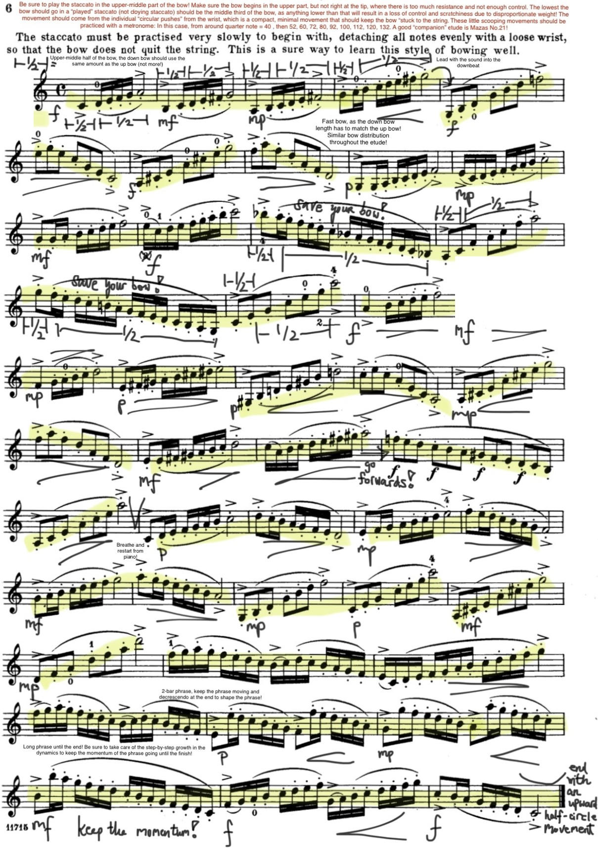

4.

Separation of phrases

I J ff? I

> o